1)Install git.

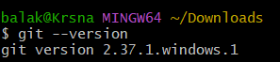

2)Create a repo in github with README.md and .ignore file.

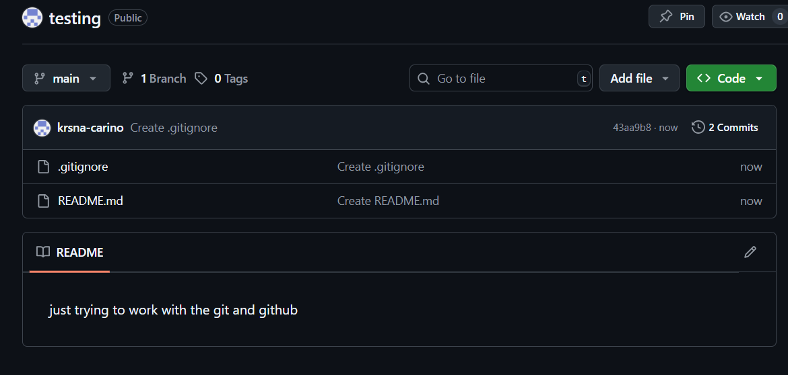

3)Clone the created repo to local.

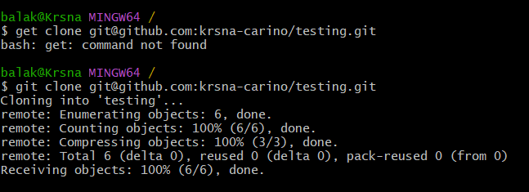

4)Create two files in local repo.

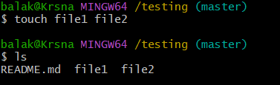

5)Commit two files and push to central Repository.

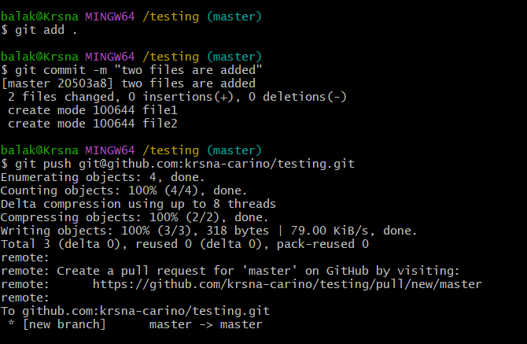

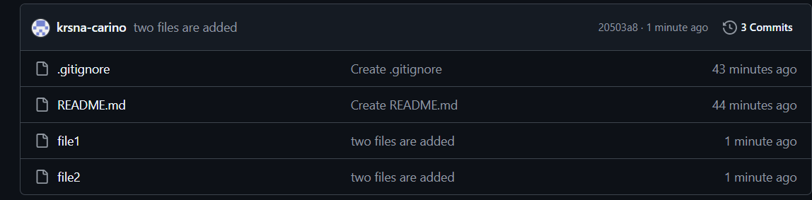

6)Create a branch in local and create a sample file and push to central.



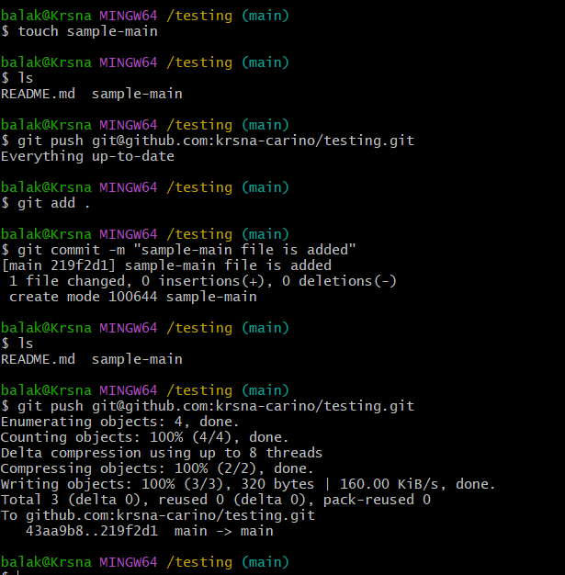

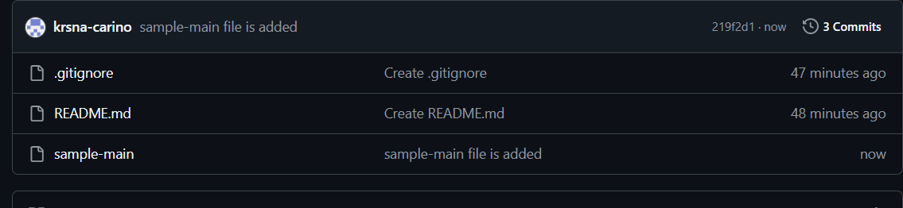

7)Create a branch in github and clone that to local.

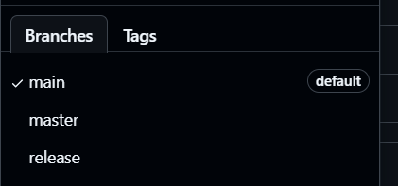

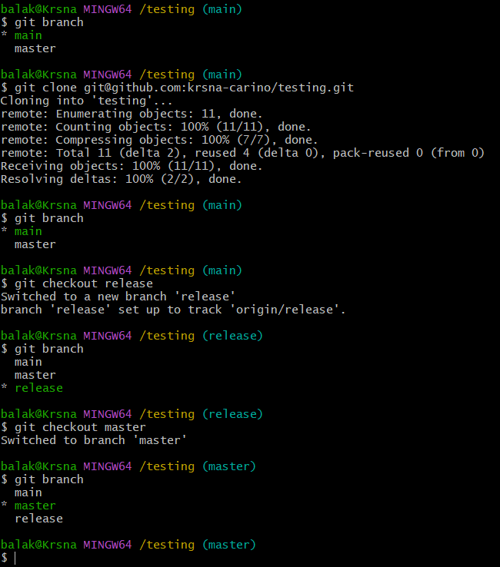

8)Merge the created branch with master in git local.

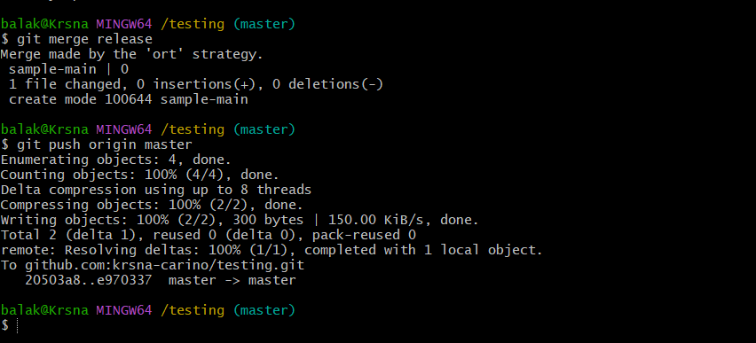

9)Merge the created branch with master in github by sending a pull request.

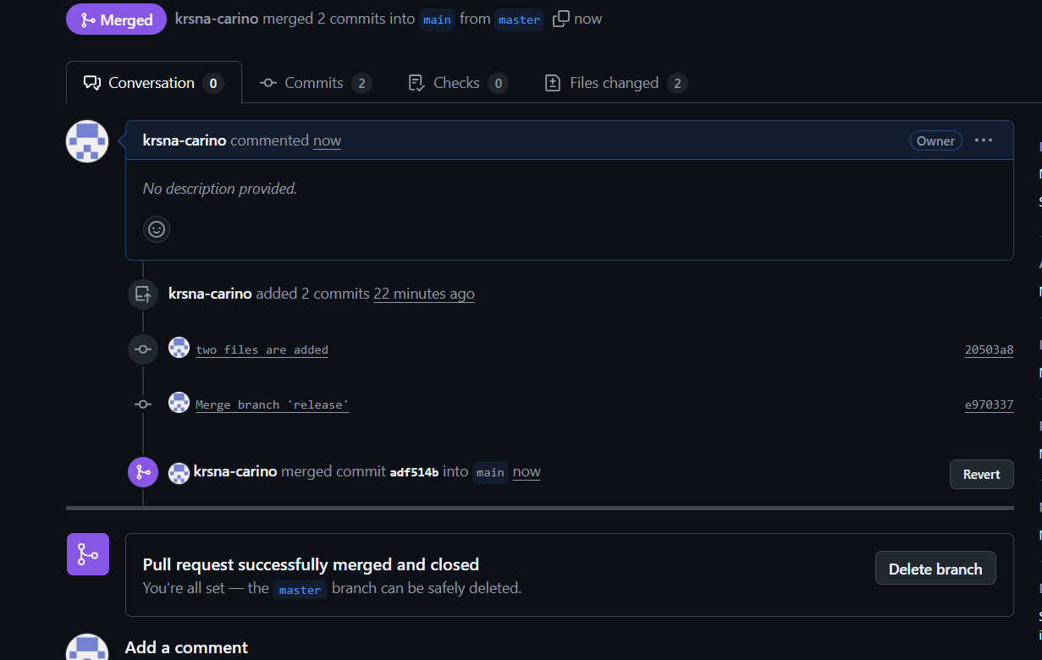

10)create a file in local and send that to branch in github.

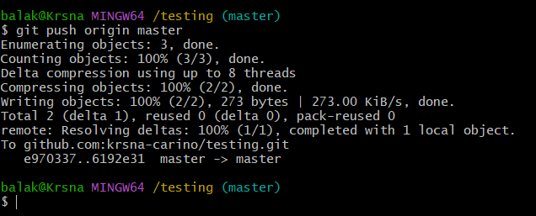

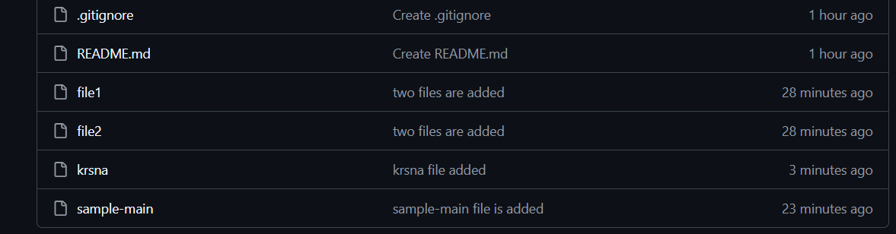

11)clone only a branch from github to local.

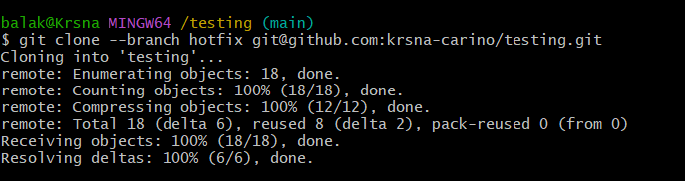

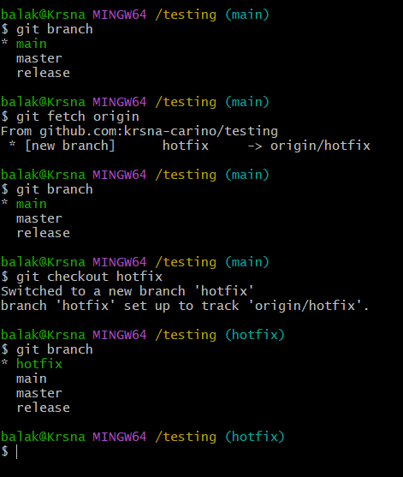

12)create a file with all passwords and make that untrackable with git.

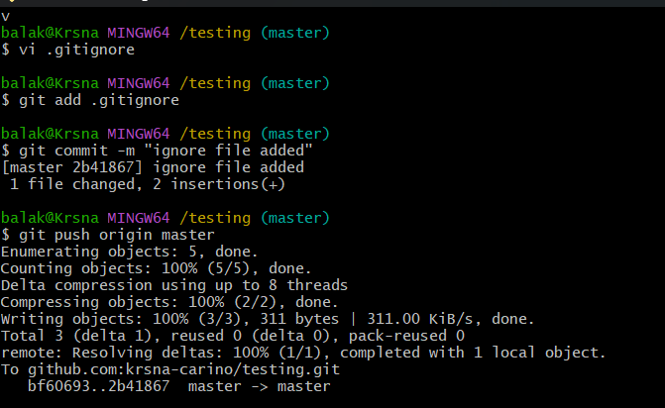

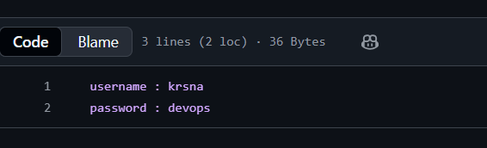

13)make a commit and make that commit reset without savings changes.

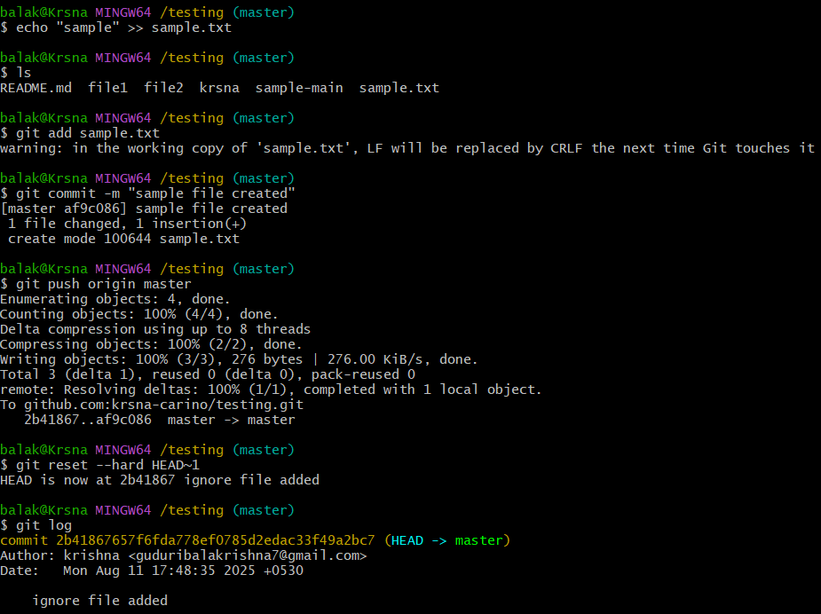

14)Revert a commited commit to the older version.

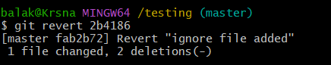

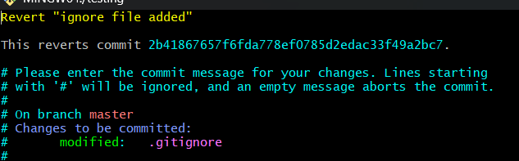

15)push a file to stash without savings the changes and work on another file.

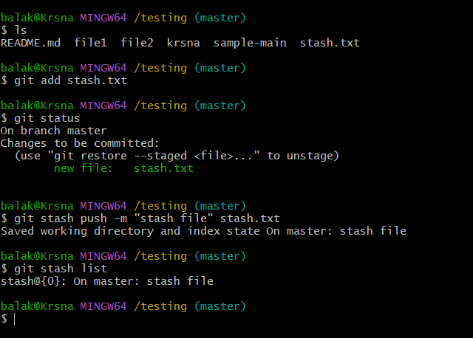

16)undo the stash file and start working on that again.

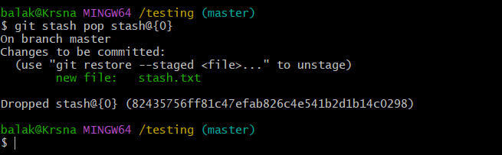

17)generate a ssh-keygen and configure into github.

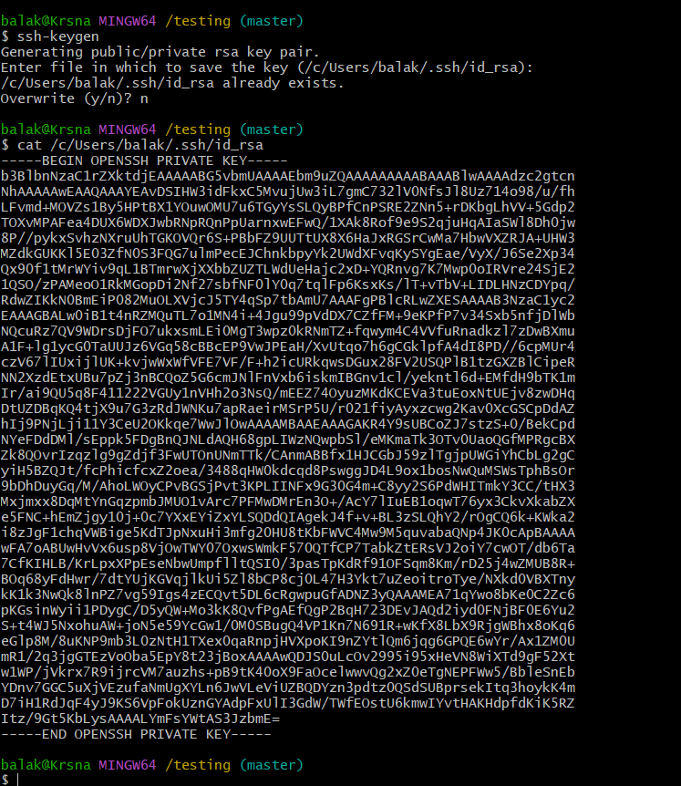

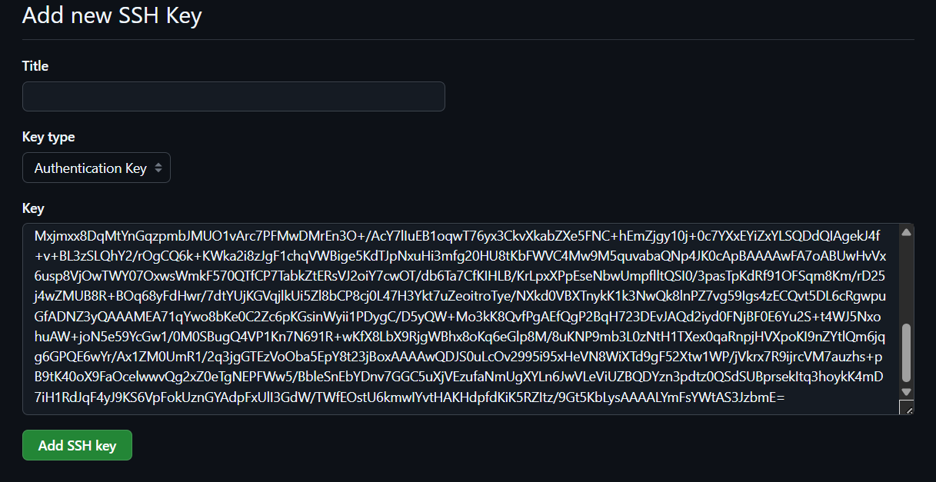

18)configure webhooks to github

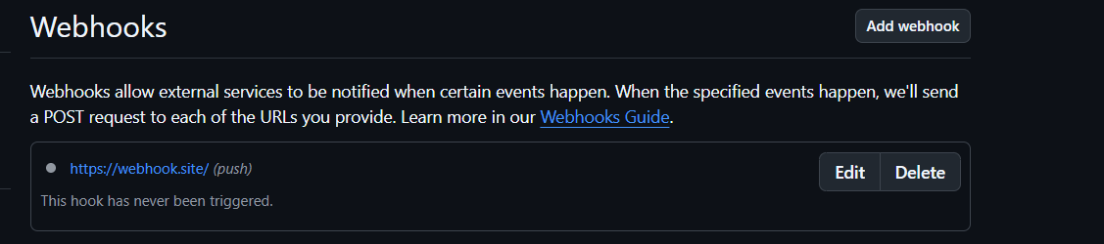

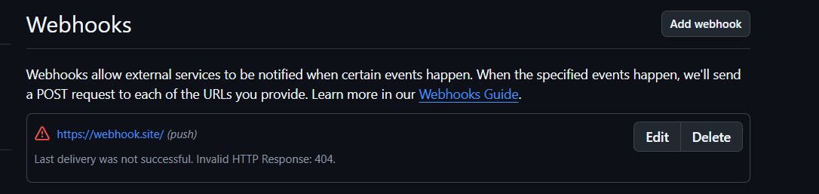

19)basic understanding of .git file.

* The .git folder keeps **all your project’s history and settings**.
* It tracks changes and stores information about **branches and commits**.
* Don’t delete or change it manually, or you’ll lose your Git data.

20)Check all the logs of git.

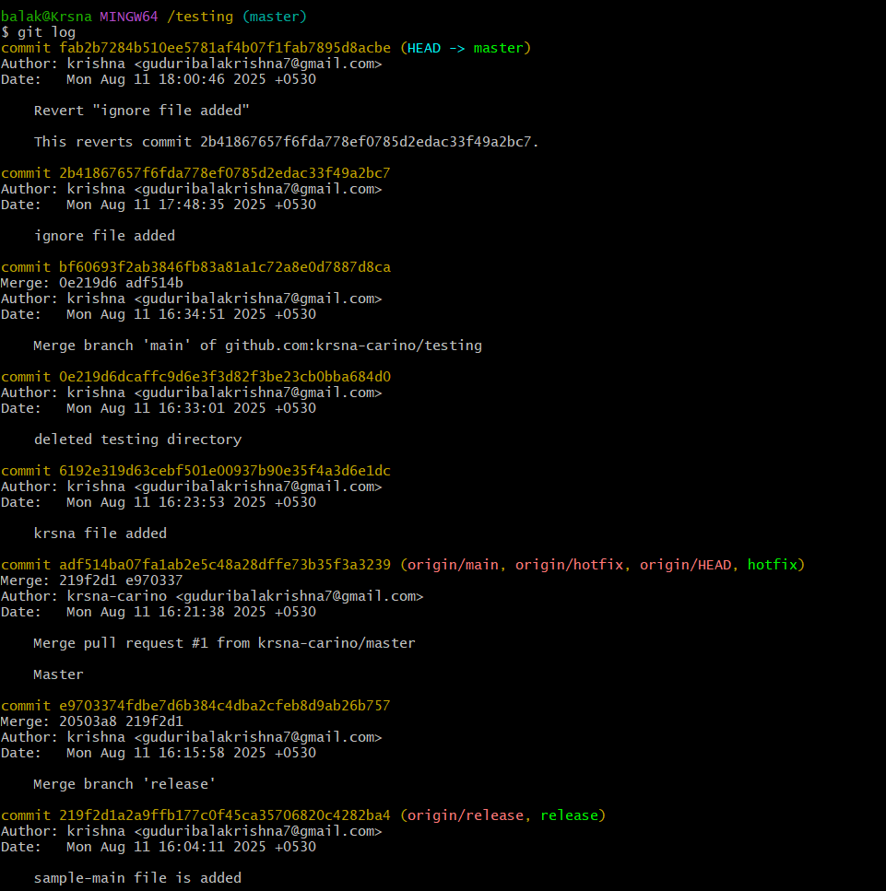

21)Rename the commit message.

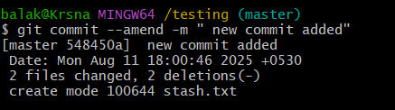

22)Merge multiple commits into single commit.

